**Spring Boot Project**

**Downloading Jar file from spring initializer**

**Creating a Maven Project**

**Output**

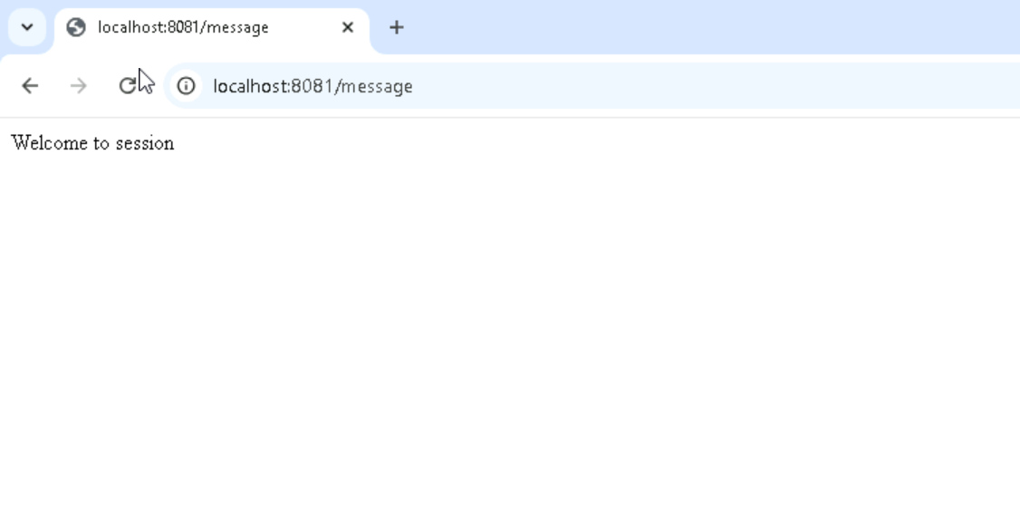

**Making a repository in GIT hub**

**In Jenkins created a free style project and deployed git project on jenkins**

**Created Docker File**

**Building Docker Image**

**Docker Image Generated**

